Inferential listening
In order to understand the context, listeners are not only required to use their analytical skills in perception.

Analytical Listening

Analytical listening is focused more on the interpretation and meaning of the actual sound. The message of the song and even the way a vocal line has been delivered, share common traits of analytical listening. Understanding the mood that the song is setting out to portray is another analytical listening trait.

Verbal Communication
People use verbal communication to express themselves in many ways during discussions, speeches, and everyday conversations. Just how effective this style of communication is can vary. It will depend on a number of verbal communication skills, such as the volume of your voice, the tone you use, the clarity of your speech, and the caliber of the words you use. You’ll probably get some idea of how effective your communication is through the feedback you receive.

Nonverbal Communication
Nonverbal communication involves communicating without using words. Although nonverbal communication can emphasize spoken words, it can also contradict them.
The three main aspects of nonverbal communication are tone of voice, body language, and eye contact, each of which has an impact on how people receive your message.
- Tone of Voice: The volume, pitch, and pace of your voice display your feelings. It can help other people determine whether you’re upset, confident, angry, etc.
- Body Language: Body language is probably the clearest type of nonverbal communication. It can tell a person a lot about how you feel. If someone sees that your arms are folded while speaking to you, they will likely feel you are not very receptive to what they have to say, whereas if you face the speaker with your arms at your sides, you will appear more interested.
- Eye Contact: Making eye contact lets a speaker know you are interested in their message. It can also help you stay engaged in the conversation and better understand the speaker.

Types of nonverbal communication
The many different types of nonverbal communication or body language include:
Facial expressions. The human face is extremely expressive, able to convey countless emotions without saying a word. And unlike some forms of nonverbal communication, facial expressions are universal. The facial expressions for happiness, sadness, anger, surprise, fear, and disgust are the same across cultures.
Body movement and posture. Consider how your perceptions of people are affected by the way they sit, walk, stand, or hold their head. The way you move and carry yourself communicates a wealth of information to the world. This type of nonverbal communication includes your posture, bearing, stance, and the subtle movements you make.
Gestures. Gestures are woven into the fabric of our daily lives. You may wave, point, beckon, or use your hands when arguing or speaking animatedly, often expressing yourself with gestures without thinking. However, the meaning of some gestures can be very different across cultures. While the “OK” sign made with the hand, for example, usually conveys a positive message in English-speaking countries, it's considered offensive in countries such as Germany, Russia, and Brazil. So, it's important to be careful of how you use gestures to avoid misinterpretation.
Eye contact. Since the visual sense is dominant for most people, eye contact is an especially important type of nonverbal communication. The way you look at someone can communicate many things, including interest, affection, hostility, or attraction. Eye contact is also important in maintaining the flow of conversation and for gauging the other person's interest and response.
Touch. We communicate a great deal through touch. Think about the very different messages given by a weak handshake, a warm bear hug, a patronizing pat on the head, or a controlling grip on the arm, for example.
Space. Have you ever felt uncomfortable during a conversation because the other person was standing too close and invading your space? We all have a need for physical space, although that need differs depending on the culture, the situation, and the closeness of the relationship. You can use physical space to communicate many different nonverbal messages, including signals of intimacy and affection, aggression or dominance.
Voice. It's not just what you say, it's how you say it. When you speak, other people “read” your voice in addition to listening to your words. Things they pay attention to include your timing and pace, how loud you speak, your tone and inflection, and sounds that convey understanding, such as “ahh” and “uh-huh.” Think about how your tone of voice can indicate sarcasm, anger, affection, or confidence.

CLAUSES
A clause is a group of words that contains a subject and a verb that have a relationship. This relationship is crucial; a clause conveys information about what that subject is or is doing, rather than simply being a random grouping of words.

Types of clauses

Independent clauses
An independent clause is a clause that can stand on its own as a distinct sentence. Take a look at these examples:
- I love eating cookies.
- My dog barks a lot.
- The kids ate lunch.
- His truck is green.

Dependent clauses
In contrast, a dependent clause is not a complete sentence. Dependent clauses are sometimes known as subordinate clauses. As their name implies, these clauses depend on independent clauses to clearly express ideas. Here are a few examples of dependent clauses:
- When I grow up
- Although he sings well
- The mouse that was hiding
To turn these dependent clauses into full sentences, you need to combine them with independent clauses:
- When I grow up, I want to be a doctor.
- Although he sings well, he hates karaoke.
- I searched through the basement and found the mouse that was hiding.
When all of your clauses are independent clauses, you can combine them using a coordinating conjunction. In English, the coordinating conjunctions are:
For, and, nor, but, or, yet, so

SUB-ORDINATING CONJUNCTION
- The fun can begin now that the clown is here.
- While we slept, the plane reached its destination.
- Before you leave, remember to take a goodie bag!
- The pool is open daily until the temperature drops.

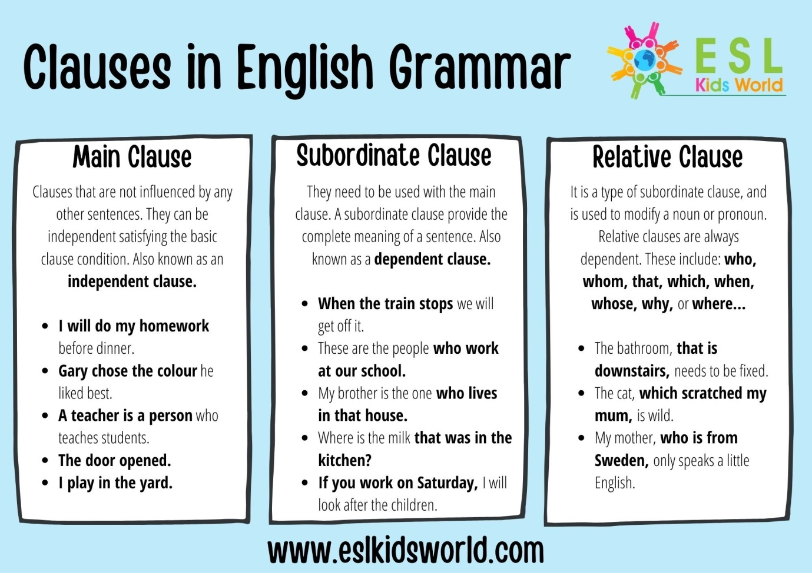

Active voice & Passive Voice
Active voice
In the active voice, the sentence’s subject performs the action. Here are two examples of sentences in the active voice:
Shira likes birdwatching.
She loves twilight.

Passive voice
In the passive voice, the action’s target is the focus, and the verb acts upon the subject. Or, to put it in the passive voice, the subject is acted upon by the verb. Every sentence in the passive voice contains two verbs
Birdwatching is liked by Shira.
Twilight is loved by her.
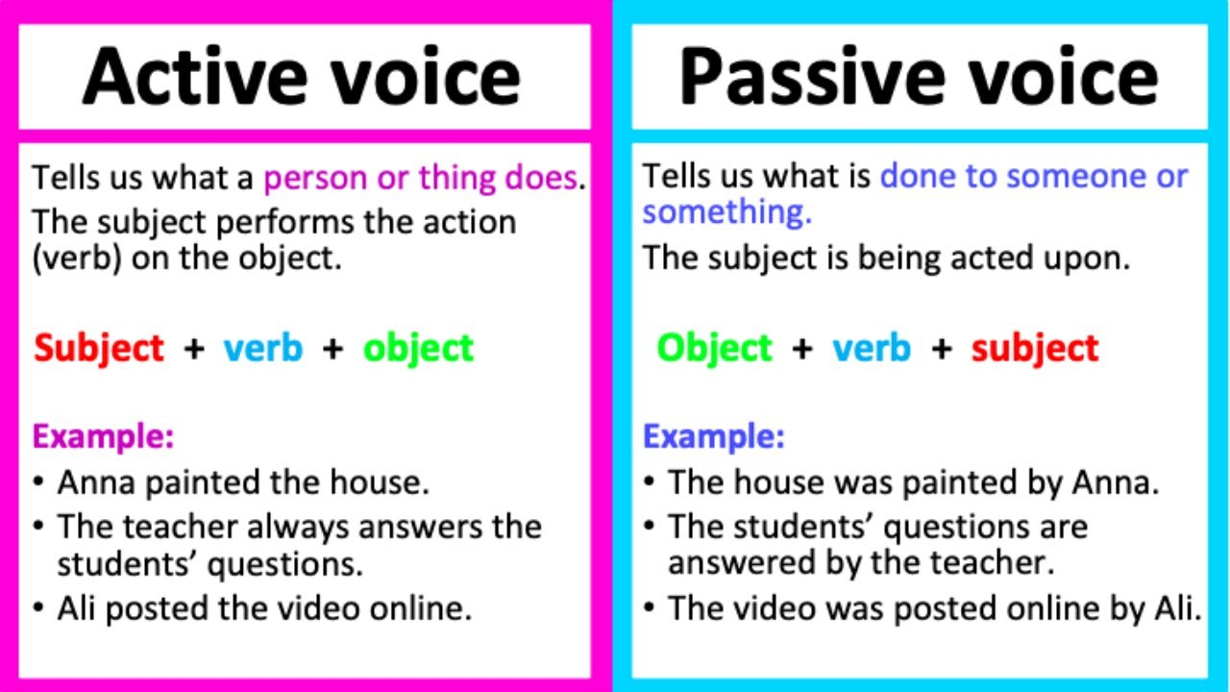

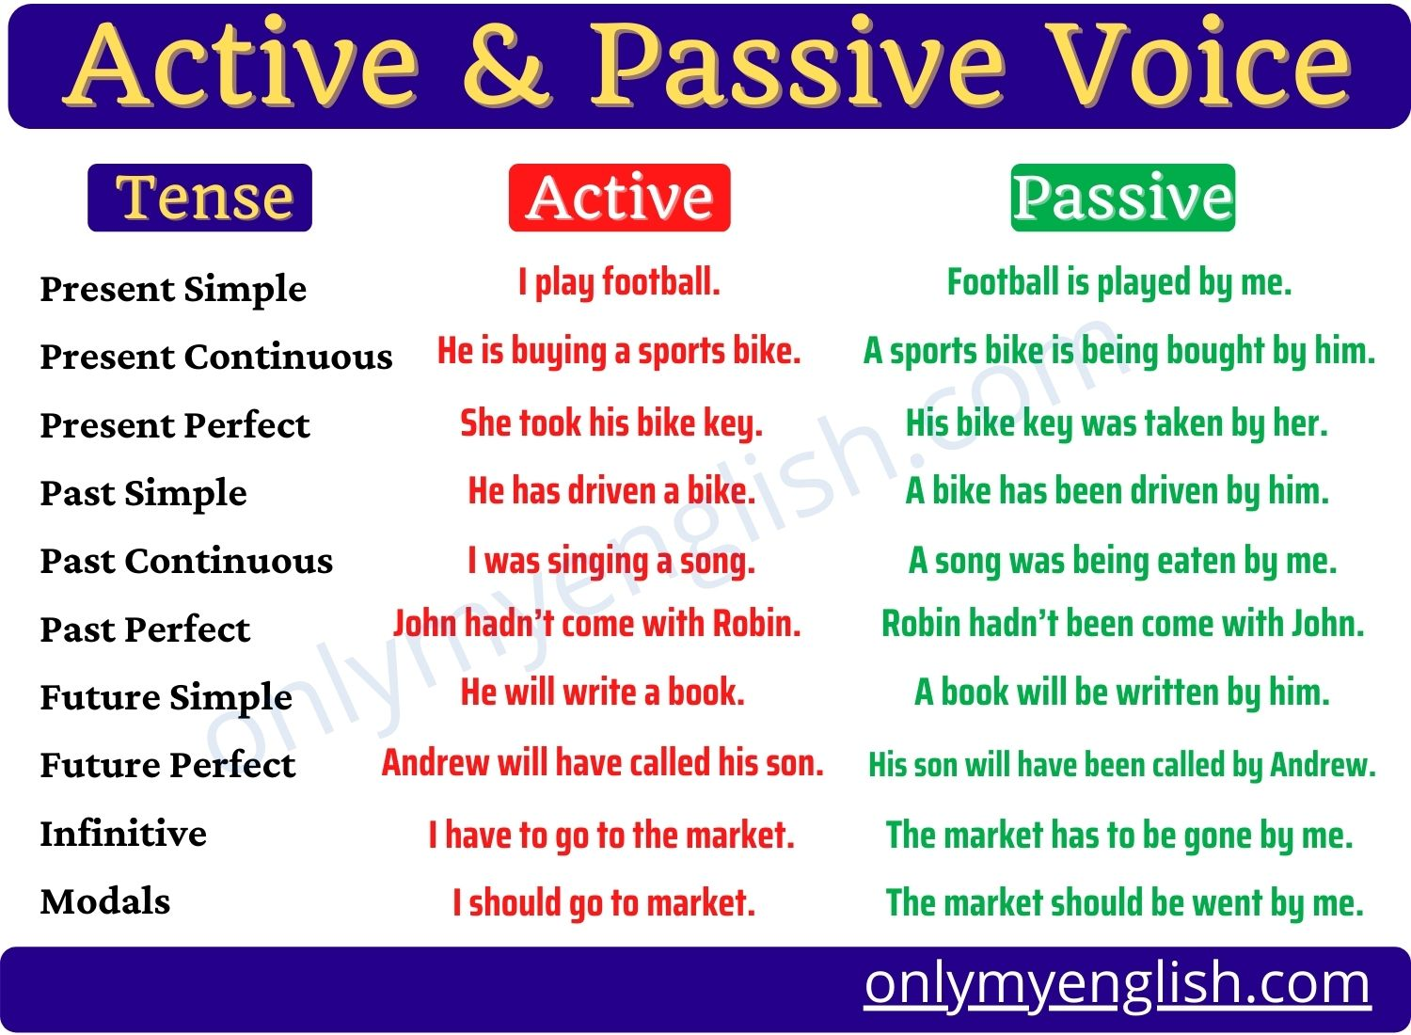

Degrees of Comparison
A degree of comparison is a form of adjective that is used to compare a person or thing possessing the same quality with another.

The Three Degrees of Comparison
- Positive Degree of Comparison
- Comparative Degree of Comparison
- Superlative Degree of Comparison

Positive Degree of Comparison
The positive degree of comparison is basically the original form of the adjective. This degree does not allow you to make any comparison. It only gives the audience the information about a particular quality possessed by a noun.
For example:
- Lisa is happy.
- This dress is pretty.
- He looks handsome.
- Meena is tired.
- The sun is bright.

Comparative Degree of Comparison
The comparative degree of comparison is used to compare between two nouns that have the same quality or the particular quality of a noun at two different times. It shows which one of the two has the greater or lesser degree of the particular quality being referred to.
For example:
- Tina looks sadder than Katie.
- This bed is more comfortable than the other bed.
- The sun is brighter than yesterday.
- Your hair is longer than hers.
- My brother is taller than me.

Superlative Degree of Comparison
The superlative degree of comparison is the highest degree of comparison. It is used to compare the similar qualities shared by more than two nouns. It shows which of these nouns being compared has the greatest or least degree of the mentioned quality or qualities.
For example:
- We climbed the highest mountain.
- The last group was the best of all.
- The Himalayas are the longest mountain ranges.
- Sanjana is the tallest girl in our gang.
- Adharsh is the most silent boy in class.

Positive Degree of Comparison | Comparative Degree of Comparison | Superlative Degree of Comparison
Santana is tall. | Santana is taller than Brittany. | Santana is the tallest of all the girls.
She is pretty. | She is prettier than her sister. | She is the prettiest.
Sam is intelligent. | Sam is more intelligent than Tina. | Sam is the most intelligent kid in class.

Form Comparatives/Superlatives when the Positive ends in -y
When the positive form ends in -y, preceded by a consonant, the 'y' is changed into 'i' before the endings -er and -est are added.
Let's take a look at the examples to understand how it's done:
Positive - happy; Comparative - happier; Superlative - happiest
Positive - wealthy; Comparative - wealthier; Superlative – wealthiest

Formation of Comparaitve/Superlative When the Positive Ends in a Consonant
When the positive ends in a single consonant preceded by a short vowel, the consonant is doubled before adding er and est.
Let's take a look at the examples to understand how it's done:
Positive - red; Comparative - redder; Superlative - reddest
Positive - thin; Comparative - thinner; Superlative – thinnest

Formation of Comparative/Superlative when the Adjective has More Than Two Syllables
When the adjective has more than two syllables, the comparative and superlative degrees are formed by putting 'more' and 'most' before the positive form respectively.
Let's understand how it's done with the help of these examples:
Positive - beautiful; Comparative - more beautiful; Superlative - most beautiful
Positive - difficult; Comparative - more difficult; Superlative - most difficult

Irregular Forms of Comparison
Some adjectives are compared irregularly, that is, their comparatives and superlatives are not formed from their positive adjectives.
To understand this rule, let's take a look at the given examples:
Positive - good; Comparative - better; Superlative - best
Positive - bad; Comparative - worse; Superlative - worst
Positive - much; Comparative - more; Superlative - most
Positive - far; Comparative - farther; Superlative - farthest
Positive - late; Comparative - later, latter; Superlative - latest, last
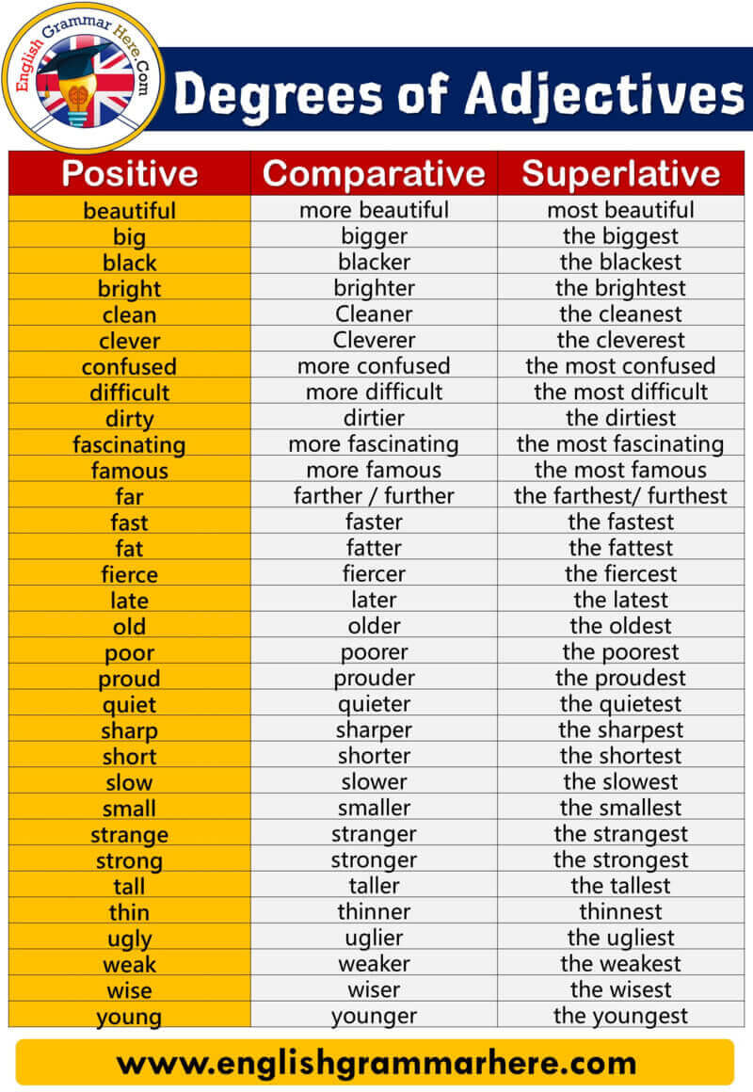
Conditional clause

Conditional sentences consist of a main clause and a conditional clause (sometimes called an if-clause). The conditional clause usually begins with if or unless. The conditional clause can come before or after the main clause.

We’ll be late if we don’t leave now.
We’ll be late unless we leave now.
If we don’t leave now, we’ll be late.

Reading comprehension
Reading comprehension is the ability to read text, process it and understand its meaning. It relies on two, interconnected abilities: word reading (being able to decode the symbols on the page) and language comprehension (being able to understand the meaning of the words and sentences).

